1. The soil C pool data was calculated from Table 2.

The paper does not report carbon density directly. We calculated carbon density from Table 2, which reported percent organic matter and bulk density, but not carbon concentration. To calculate carbon density, their data were entered into a spreadsheet, then processed with SAS code to calculate carbon density. The calculation steps were as follows:

a. Convert organic matter (OM) to organic carbon units.

We used the following equation developed by James Holmquist (in review):

SoilCC=0.074*(OM/100)*(OM/100) + 0.421*(OM/100) - 0.0080, where

SoilCC = C concentration in units of grams C per grams soil

OM = organic matter concentration in units of grams OM per grams soil

b. Convert soil carbon concentration (SoilCC) to carbon density.

SC=SoilCC*BD, where

SC=Soil carbon density in units of grams carbon per cubic centimeter (g/cm3)

c. Soil carbon accretion rate (SCrate) was calculated from the soil C and accretion rates from table 2.

SC_rate= SC * Accretion_rate*10000 (SC_rate unit is g C m2 yr-1).

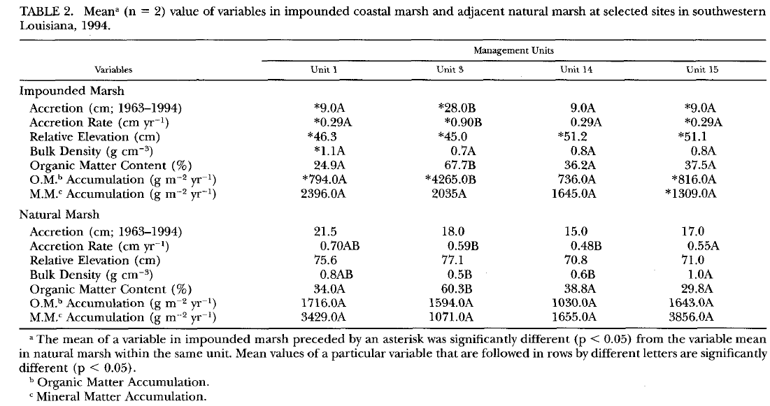

History of the checking processes by Meng.

Meng can’t repeat the calculation.

***[Response from Blanca]*** *This is the formula for gC/cm3, 1.1*0.249/2, for the first one. Please update all accordingly. Calculate the C pool from that multiplying by depth, to get gC/m2 after changing units (from cm to m, etc).*

Done as suggested.